**Image Encryption using Triple DES**

**Abstract:**

This document presents a comprehensive methodology for enhancing the security of the Triple Data Encryption Standard (Triple-DES) algorithm. The methodology focuses on strengthening the encryption process through the use of multiple encryption modes, key management strategies, and feedback mechanisms. Key components of the methodology include the generation and management of three 64-bit keys, the introduction of new encryption modes such as Cipher Block Chaining (CBC) with external feedback, and the incorporation of feedback mechanisms to improve the randomness and unpredictability of the encrypted data. Additionally, the document discusses the design rationale behind the methodology, emphasizing the need for high security without excessive computational complexity. The proposed methodology aims to address vulnerabilities present in earlier encryption schemes and provide increased protection against cryptographic attacks. Overall, the document outlines a robust methodology for Triple-DES encryption, offering organizations a framework to strengthen the security of their data and communications.

**Table of Contents:**

- Abstract

- Table of Contents

- Introduction

- Existing Methods

- Proposed Method with Architecture

- Methodology

- Implementation

- Conclusion

**Introduction:**

In the digital age, securing sensitive information is crucial, particularly for visual data such as images, which can contain confidential information from personal, medical, and financial sectors. Image encryption ensures that these data remain protected from unauthorized access and tampering.

Cryptographic techniques are essential for this protection, with the Triple Data Encryption Standard (3DES) being a significant method. 3DES, an enhancement of the original Data Encryption Standard (DES) developed by IBM in the 1970s and adopted by the National Institute of Standards and Technology (NIST), addresses DES's vulnerabilities through a process of triple encryption. This involves three distinct keys, enhancing security and making it significantly harder to break.

Although newer algorithms like the Advanced Encryption Standard (AES) offer faster and more secure encryption, 3DES remains widely used in legacy systems and applications requiring high compatibility, such as banking and government sectors.

This report explores the application of 3DES for image encryption, ensuring the confidentiality and integrity of visual data during storage and transmission. It provides a detailed overview of existing encryption methods, the architecture of the proposed 3DES-based method, and a step-by-step implementation guide.

In conclusion, while acknowledging the advancements in encryption technology, the report reaffirms 3DES's relevance for securing images, offering a reliable solution for protecting sensitive visual information in our increasingly digital world.

**Existing methods:**

The existing method revolves around the Triple-DES algorithm, which is an enhancement of the original Data Encryption Standard (DES). The existing method involves the use of three 64-bit keys (K1, K2, K3) to encrypt data in multiple rounds. It employs a combination of encryption and decryption operations to enhance security and protect against various cryptographic attacks.

The existing method utilizes the Cipher Block Chaining (CBC) mode with external feedback to provide advantages such as backward compatibility with single-key DES encryption, limited error propagation, resistance to exhaustive key search attacks, and increased security against linear and differential cryptanalysis. It also addresses concerns related to the block size and potential vulnerabilities present in earlier encryption schemes.

Furthermore, the existing method highlights the importance of key management, encryption modes, and the impact of advancements in technology on the security of encryption algorithms. It emphasizes the need for robust encryption techniques to withstand evolving threats and ensure the confidentiality and integrity of sensitive data.

**Proposed method with Architecture:-**

The proposed method focuses on enhancing the security of the Triple-DES algorithm through the introduction of new encryption modes. The architecture outlined in the document involves utilizing multiple keys and encryption rounds to strengthen the encryption process. By incorporating intricate feedback mechanisms and careful key management, the proposed method aims to mitigate vulnerabilities present in earlier encryption schemes. We have emphasizes the importance of selecting a secure mode of operation and highlights the significance of robust encryption techniques in safeguarding data against potential attacks. Additionally, we discuss the rationale behind the design choices made in the proposed method, underlining the need for high security without excessive computational complexity.

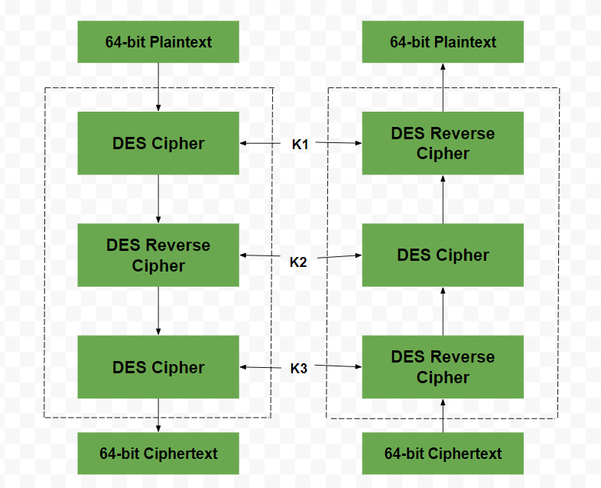

**Implementation of triple DES:-**

To implement Triple-DES (3DES), you would typically follow these steps:

1. Key Generation: Generate three 64-bit keys (K1, K2, K3) for the encryption process.

2. Encryption Process:

- Initial Permutation: Permute the input plaintext according to a fixed table.

- Round 1: Encrypt the permuted plaintext using Key K1.

- Round 2: Decrypt the output of Round 1 using Key K2.

- Round 3: Encrypt the output of Round 2 using Key K3.

- Final Permutation: Permute the output of Round 3 to get the ciphertext.

3. Decryption Process:

- Initial Permutation: Permute the input ciphertext according to a fixed table.

- Round 1: Decrypt the permuted ciphertext using Key K3.

- Round 2: Encrypt the output of Round 1 using Key K2.

- Round 3: Decrypt the output of Round 2 using Key K1.

- Final Permutation: Permute the output of Round 3 to get the original plaintext.

4. Padding: If the plaintext length is not a multiple of the block size (64 bits), padding may be required to fill the last block.

5.Mode of Operation: Choose a mode of operation like CBC (Cipher Block Chaining) or ECB (Electronic Codebook) to encrypt multiple blocks of data.

6. Key Management: Ensure secure storage and handling of the three keys to maintain the security of the encryption process.

By following these steps and considering security best practices, you can successfully implement the Triple-DES encryption algorithm.

**Conclusion:-**

The image encryption scheme using Triple DES provides a robust method for securing visual data. By leveraging the encryption capabilities of Triple DES, the scheme ensures the confidentiality and integrity of images, making them resistant to unauthorized access and tampering. While Triple DES may have some limitations compared to newer encryption algorithms like AES, it remains a viable option, especially in scenarios where compatibility and legacy support are critical.